|  |
| --- |
|  |
| **ALINX FPGA Development Board** |
| **VCU H264/H265 Codec** |
|  |
|  |
|  |

|  |
| --- |
| ALINX.png |

Version Record

|  |  |  |  |
| --- | --- | --- | --- |
| Version | Date | Release By | Description |
| Rev1.0.1 | 2021-04-18 | Rachel Zhou | First Release |

We promise that this tutorial is not a permanent, consistent document. We will continue to revise and optimize the tutorial based on the feedback of the forum and the actual development experience.

# Content

Version Record 2

Content 3

Part 1: Environment Introduction 4

Part 1.1: VCU Introduction 4

Part 2: Preparation for program operation 4

Part 2.1: Make sd Card 4

Part 2.2:Connect dp monitor 8

Part 2.3: Open the serial terminal to connect to the debug port of the board 8

Part 2.4: Log in to the system 8

Part 3: Video codec 8

Part 3.1: gst command decoding example 8

Part 3.2: gst command coding example 8

# Part 1: Environment Introduction

## Part 1.1: VCU Introduction

VCU, namely Video Codec Unit. This is a H264/H265 video codec processing module. Maximum support 3840x2160@60fps video encoding and decoding at the same time.

This module is generally integrated in the EV family of UltraScale+MPSOC. Located on the PL side, it needs to interact with the PS through the axi interface.

# Part 2: Preparation for program operation

## Part 2.1: Make sd Card

1. Connect the sd card to the ubuntu virtual machine

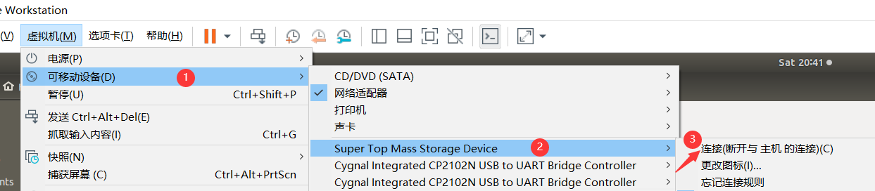

1. Open Disk tool

In ubuntu, press the win key, in the input box that appears, enter disk and click the icon pointed by the arrow below

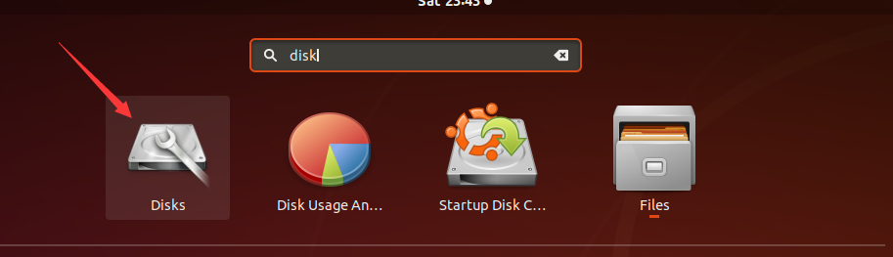

1. After selecting the following U disk, if there is already a partition, you can click the "-" button in the figure below to delete the original partition

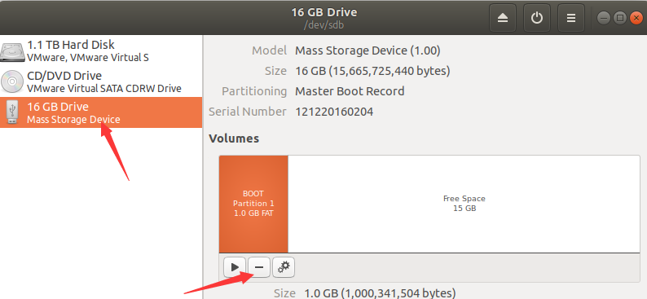

1. Create partition

Click the "+" button in the picture to add a 1G partition

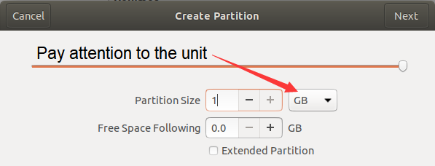

Click the Next button, in the following interface, set the partition name to BOOT, the default is FAT partition

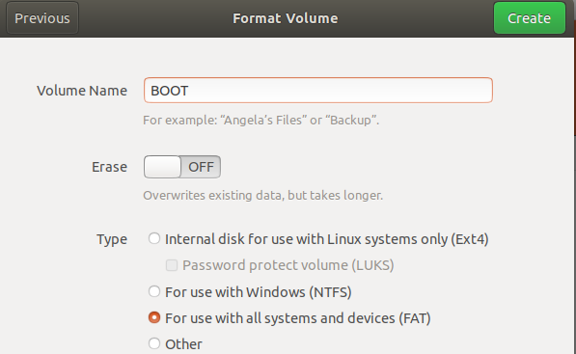

Click Create and wait for the initialization to complete

1. Create the second root file system partition

Similar to the above creation process, create a partition named ROOTFS with the format of Ext4 from the remaining U disk space

1. Mount the newly created file system

After the above partition is created, open a folder and on the sidebar, you can see the newly created partition

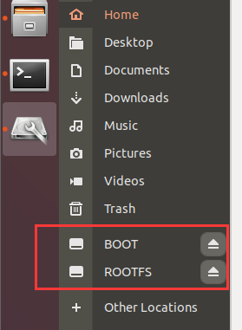

Click the two drive letters with the mouse, and the system will automatically mount the two partitions

1. Copy BOOT file

Copy the contents of the run_file/BOOT folder into the BOOT directory of the SD card

1. Unzip the file system to ROOTFS

Click on ROOTFS to enter the ROOTFS folder

Copy run_file/rootfs.tar.gz to this directory

Right-click and select the following items in the pop-up menu to open a terminal

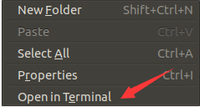

Enter the following command in the terminal to decompress the file

|  |
| --- |
| tar -zxvf rootfs.tar.gz |

1. Wait for the SD card writing to complete

After the above command is executed, close the terminal. Click the button as shown in the figure below, when these two drive letters disappear, you can dial out the U disk

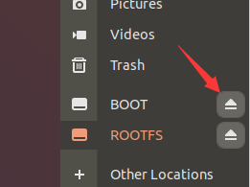

## Part 2.2:Connect dp monitor

## Part 2.3: Open the serial terminal to connect to the debug port of the board

## Part 2.4: Log in to the system

# Part 3: Video codec

## Part 3.1: gst command decoding example

Here will call the decoding unit of vcu, play the video file h264_720.mp4, and display it to the dp display.

1. Enter the directory where the video file is located
2. Enter the following command

|  |
| --- |
| gst-launch-1.0 uridecodebin uri=File:///media/sd-mmcblk1p1/h264_720P.mp4 ! queue max-size-bytes=0 ! videoconvert ! kmssink bus-id=fd4a0000.zynqmp-display fullscreen-overlay=1 |

At this time, you can see the video screen displayed on the dp monitor. If the monitor supports it, you can replace the video with another resolution video

## Part 3.2: gst command coding example

The codec unit will be used at the same time here. First, capture the usb camera data, encode it into an H264 stream, and send it to 127.0.0.1 (local) via UDP, and the port is 5000. Then through a set of commands, the network stream is received and decoded, and finally displayed on the DP display.

It should be noted that whether the format of the usb camera supports the yuyv 4:2:2 format, if not, it needs to be adjusted to the supported parameters accordingly.

1. Enter decode display command

|  |
| --- |
| gst-launch-1.0 udpsrc port=5000 buffer-size=10000000 caps="application/x-rtp, media=video, clock-rate=90000, payload=96, encoding-name=H264" ! rtph264depay ! h264parse ! video/x-h264, alignment=nal ! omxh264dec low-latency=1 ! kmssink bus-id=fd4a0000.zynqmp-display fullscreen-overlay=1 & |

1. Enter the capture camera and encode commands

|  |
| --- |
| gst-launch-1.0 -v v4l2src device=/dev/video0 ! video/x-raw,format=YUY2,width=1280,height=720 ! videoconvert ! omxh264enc num-slices=16 gop-length=1000 periodicity-idr=1000 control-rate=low-latency prefetch-buffer=true target-bitrate=20000 gop-mode=low-delay-p qp-mode=auto ! video/x-h264, alignment=nal ! rtph264pay ! udpsink buffer-size=10000000 host=127.0.0.1 port=5000 max-lateness=-1 qos-dscp=60 async=false max-bitrate=120000000 -v |